**Screenshots** – Project1 Task 2

1. **Initial page which gives option to choose a country and submit**

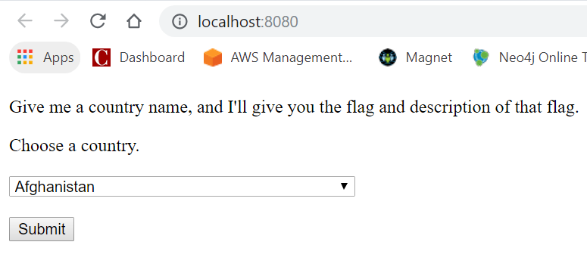

1. **After submitting Albania**

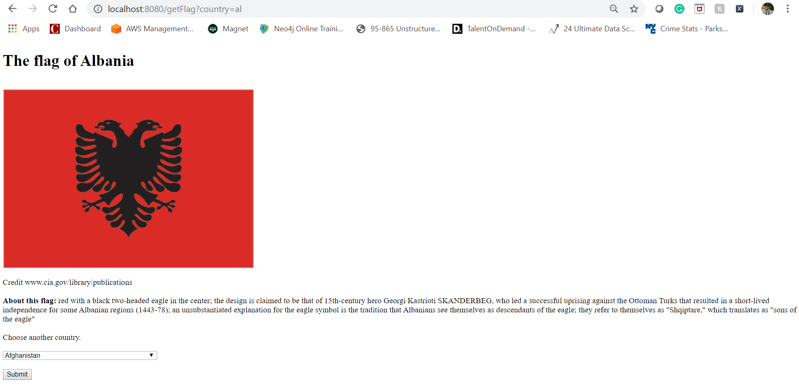

1. **Selecting “Arctic Ocean” and submitting. That doesn’t have the image but the description. It gives the message “Image not found. Please enter some other country”**

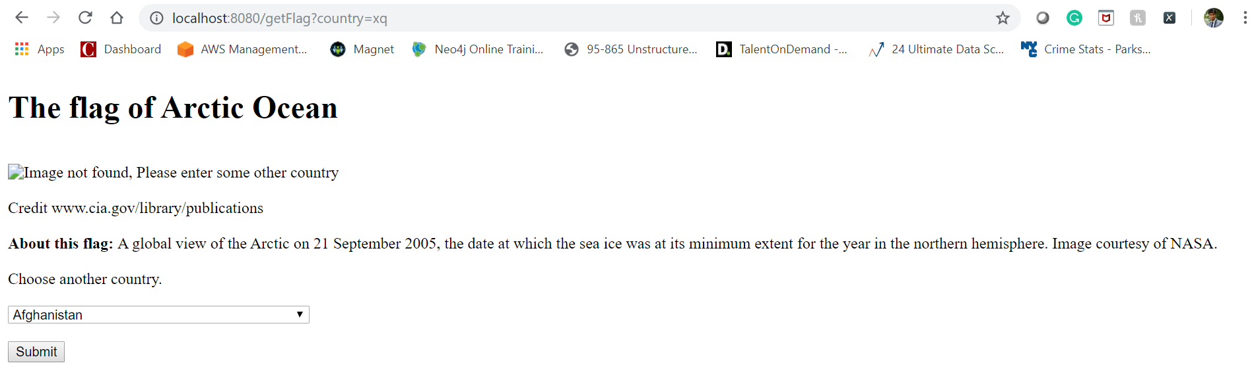

1. **Checking the mobile view, it changes the size of the image and also the doctype accordingly mobile or desktop**

